EXPERIMENT – 16
Comparison of Different Classification Algorithms and Evaluation of their Performance
AIM
To implement different classification algorithms using Python and compare their performance using suitable evaluation metrics.
APPARATUS REQUIRED
- Google Colab
- Python 3.x
- NumPy
- Pandas
- Scikit-learn
- Matplotlib
ALGORITHM
- Start the program.
- Import the required Python libraries.
- Load the Iris dataset.
- Separate the input features and target variable.
- Split the dataset into training and testing data.
- Implement different classification algorithms.
- Train each classification model using the training data.
- Predict the classes using the testing data.
- Calculate the accuracy of each classification algorithm.
- Compare the performance of the classification algorithms.
- Display the results.
- Stop the program.

PROGRAM
# Experiment 16: Comparison of Classification Algorithms
# Import required libraries
import numpy as np
import pandas as pd
from sklearn.datasets import load_iris
from sklearn.model_selection import train_test_split
from sklearn.metrics import accuracy_score
from sklearn.linear_model import LogisticRegression
from sklearn.neighbors import KNeighborsClassifier
from sklearn.naive_bayes import GaussianNB
from sklearn.tree import DecisionTreeClassifier
from sklearn.ensemble import RandomForestClassifier
# Load Iris dataset
iris = load_iris()
X = iris.data
y = iris.target
# Split the dataset
X_train, X_test, y_train, y_test = train_test_split(
X, y, test_size=0.2, random_state=42
)
# Create classification models
models = {
"Logistic Regression": LogisticRegression(max_iter=200),
"KNN": KNeighborsClassifier(n_neighbors=5),
"Naive Bayes": GaussianNB(),
"Decision Tree": DecisionTreeClassifier(random_state=42),
"Random Forest": RandomForestClassifier(
n_estimators=100, random_state=42
)
}
# Train and evaluate each model
results = {}
for name, model in models.items():
# Train the model
model.fit(X_train, y_train)
# Predict test data
y_pred = model.predict(X_test)
# Calculate accuracy
accuracy = accuracy_score(y_test, y_pred)
results[name] = accuracy
# Display results
print("Classification Algorithm Performance:\n")
for name, accuracy in results.items():
print(name, ":", accuracy)

OUTPUT
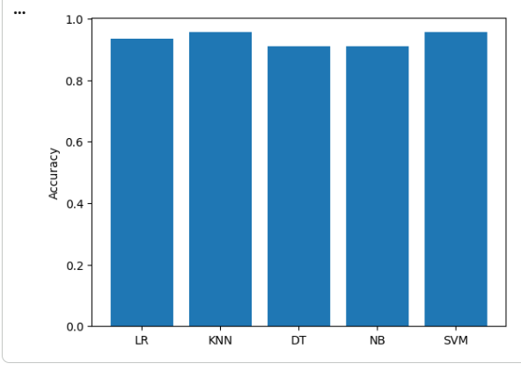
RESULT
Thus, different classification algorithms were successfully implemented using Python in Google Colab, and their performances were evaluated and compared based on classification accuracy.

